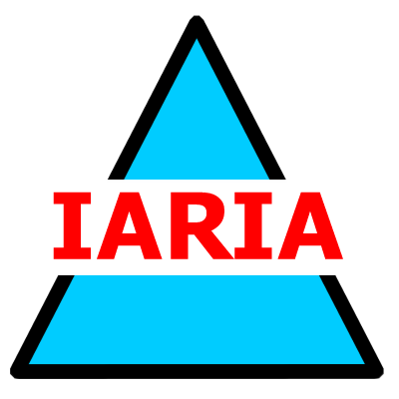  www.iaria.org | International Conference on Advances in Mesh Networks  MESH 2008  August 25-31, 2008 - Cap Esterel, France  http://www.iaria.org/conferences2008/MESH08.html

Important deadlines:
Submission deadline April 5, 2008
Notification May 15, 2008
Registration and camera ready June 1, 2008

Topics:
- Architectures and algorithms Frameworks
  - Wireless interference models
  - Topology models
  - Large-scale networks
  - Real-time and non-real-time communications
  - Channel assignment schemes
  - Resource allocation
  - Centralized and distributed scheduling
  - Performance
  - Static/mobile scenarios
  - Access control
  - Service differentiation
- Protocols Protocol interference models
  - Access and routing protocols
  - Single-channel multihop / multi-channel routing
  - Joint routing and scheduling
  - Routing metrics
  - Multichannel routing
  - Quality of Services routing
  - Multimedia-centric routing
  - Fast-link quality metrics
  - Bandwidth estimation
  - Cross-layer multicast routing
- Applications Multimedia services
  - Home IPTV
  - WiMax
  - Broadband home networking communications
  - Emergency/disaster
  - Telemedicine and e-health
  - Smart buildings
  - Broadband Internet access

