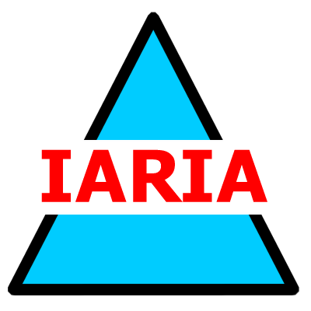  www.iaria.org | The Second International Conference on Emerging Security Information, Systems and Technologies  SECURWARE 2008  August 25-31, 2008 - Cap Esterel, France  http://www.iaria.org/conferences2008/SECURWARE08.html

Important deadlines:
Submission deadline April 5, 2008
Notification May 15, 2008
Registration and camera ready June 1, 2008

Tracks:
- ARCH: Security frameworks, architectures and protocols
- SECMAN: Security management
- SECTECH: Security technologies
- SYSSEC: System security
- INFOSEC: Information security
- MALWA: Malware and Anti-malware
- ANTIFO: Anti-forensics
- PRODAM: Profiling data mining
- SECHOME: Smart home security
- SECDYN: Security and privacy in dynamic environments
- ECOSEC: Ecosystem security and trust
- CRYPTO:Cryptography

