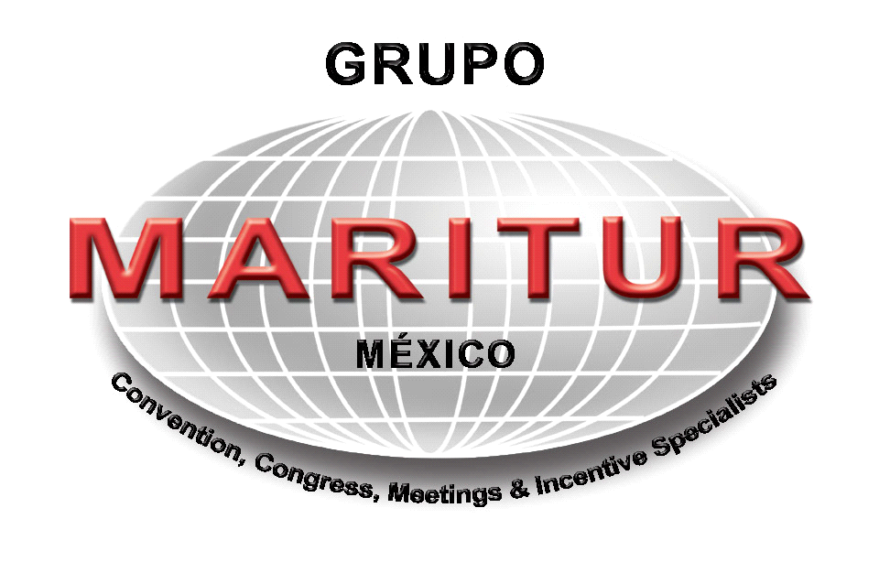

Welcome to Cancun........................

Reading this letter of instruction will answer most if not all of your questions. It is imperative that everyone be prepared with your proof of citizenship and be timely about your flights............. If you do this, everything else will be fine!

Digital World 2009 trip will be as active or as quiet as you would like it to be. Take advantage of any of the activities available to your group, or on an individual basis. There will be a Hospitality Desk dedicated specially for your group to answer any questions you may have for the duration of your stay.

TO CANCUN :
You must have your proof of citizenship with you at check in. This must be one of the following: 1) a valid passport or 2) original birth certificate with drivers license or 3) certified copy of your birth certificate with your drivers license. You will not be permitted to board your aircraft without one of these. If you live in the USA, please note that,
as of December 31, 2006, travelers to and from Canada, Mexico, Central and South America, the Caribbean, and Bermuda will be required to have a passport or other secure, accepted document to enter or re-enter the United States. This requirement will apply to all air and sea travel and will be extended to all land border crossings by December 31, 2007.
Please check with your Government about this Initiative.

Please remember that if you are bringing a child with you and they do not have the same surname, you must carry a notarized letter from the parent(s) saying that you have permission to take them out of the country. They will not be permitted to board without this document.

Your are permitted two checked pieces of luggage and one carry on plus a purse or lap top computer. The airlines have become very sensitive to the number of bags being checked and carried on as well as the weight of these bags. Any one bag cannot exceed 60 pounds in weight,
otherwise you are subject to a surcharge. Your golf bag counts as one checked piece of luggage. Please do not carry on scissors, nail files or anything which can be construed as a weapon. You may take these items, but they must be packed in your checked bags. Lastly, if you need medications with you, make sure to carry them in the prescription bottle. If you cannot be without a medication, take an extra prescription written by your physician in case you lose your medication. If you cannot see without your glasses, take an extra pair! Remember, lighters are now banned from carry-on baggages.

IMPORTANT: ARRIVAL CANCUN INTERNATIONAL AIRPORT
Before landing, be sure to have the FM-T Immigration form filled out, it is one per person. Take your time to fill it out, including the attachment on the bottom, which will serve as a “Tourist Card” during your stay in Mexico, please keep it in a safe place and do not lose it, you will be asked for this document. Upon your departure return the “Tourist Card” to your airline clerk so that Mexican Immigration can have record of it.

Once you arrive into the Cancun Airport, you will clear Mexican Immigration using your proof of citizenship or passport, and your FM-T Immigration form. Then, proceed to the luggage carousel, secure your bags and head for the Customs official. While on your flight into Mexico, you will be given a Mexican Customs form to complete. The Customs Official will take this form from you, but you will also be asked to push a button at the "traffic light" where he or she will be standing. Only one per party will be asked to push the button. If it goes green, you will be permitted to exit the airport. If it goes red, you are subject to questioning and an inspection of your luggage (this is a routine inspection that should take a few minutes) It's the luck of the draw, so don't feel alone if it turns red!

Having completed this exercise, walk through the hall way and to your left you will see Maritur Booth #12, as indicated in the map below. Maritur staff, wearing RED SHIRTS and BEIGE PANTS will be holding a sign with your Group Name or Personal Name. After locating Maritur staff, you will be escorted to your scheduled means of transportation and transferred to your hotel.

Note : Do not stop and talk to any “time share” , taxi or any other person trying to sell you transfers. ONLY MARITUR STAFF. ( see map below )

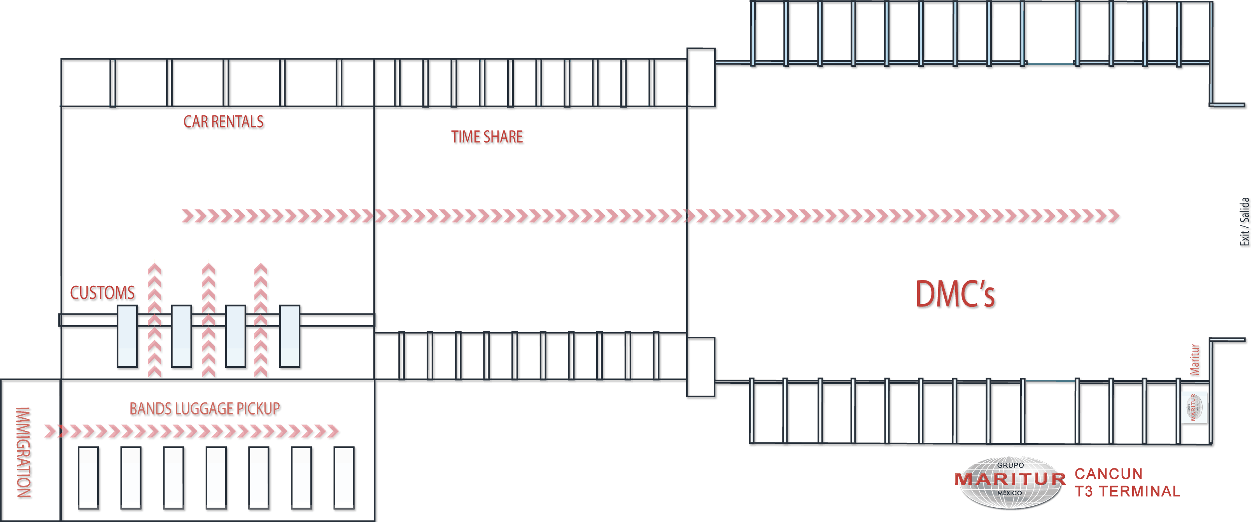

AIRLINES ARRIVING AT CANCUN T3 TERMINAL
Air Europa | Northwest
Alaska Airlines | Spirit
American Airlines | Sun Country
American Transfer | Thompson
Continental | Thomas Cook
Delta | United
Frontier | US Airways
Iber World | US 3000
LTU | Orbest
My Travel

Remarks: Please note that this list is subject to be changed by Airport Authorities

Additional Information:

Average Weather Conditions : °F
Jan. | Feb. | Mar. | April | May | June | July | Aug. | Sept. | Oct. | Nov. | Dec.
74 | 75 | 78 | 80 | 82 | 84 | 84 | 84 | 83 | 81 | 78 | 76

Average number of days with precipitation :
Jan. | Feb. | Mar. | April | May | June | July | Aug. | Sept. | Oct. | Nov. | Dec.
5 | 4 | 3 | 2 | 4 | 6 | 4 | 4 | 7 | 8 | 5 | 6

Attire : Cancun has tropical weather and you can wear casual clothing for most entertainment activities although some restaurants & bars requests a dress code this is limited to wearing long pants and shoes. We recommend to bring with you cotton garments (light colors), jeans, short and long pants, tennis shoes, hat, swimsuit, sandals. If you forget something don't worry, in Cancun you can get any of these items in any of the clothing stores located all over the hotel zone and downtown.

English is spoken everywhere in Cancun. There may be instances where some staff members at the hotel may not be able to communicate with you because their only language is Spanish, but there is always someone not far away who can help you.

Currency in Mexico is the Mexican Peso. The U.S. Dollar is taken almost everywhere. However, retail stores will make the exchange rate available to you at the point of purchase when using the dollar, but don't expect a great rate as you are paying for the convenience. Credit cards are taken universally, although I would not expect a Discover card to be accepted all the time.

Security in Cancun is generally not an issue. The best advice is simply to be as prudent as you would be in any place with which you are not familiar or in any large city. The locals are very warm and helpful by nature, but just like at home, you cannot expect that everyone will be this way. Additionally, there are plenty of other visitors who come to Cancun just to prey on unsuspecting vacationers. There is a safe in your room, but the hotel staff will tell you that they are not responsible for lost or stolen items. The front desk can also secure any valuables you may have in their safe. I would always ask for a receipt when relinquishing possession of such an item. You do not need to take any valuable jewelry with you on this trip! Ask yourself how much you care if your favorite piece disappears and then decide if you should leave it at home.

Electricity at your hotel is 110 just like at home.

Cancun has a very sophisticated water purification operation. However, many people have very sensitive "systems". We recommend not to drink tap water; buy bottled water instead. Be careful about what you drink (ice) or eat (washed salads). Most in the group will not have a problem, but some will and you probably already know which one you are. Just be prepared!

To Call Mexico: If you are calling Mexico from the United States.
- Dial the international access code : 011
- Dial the country code : 52
- Dial the 2 or 3 digit area code , then the 8 or 7 digit number.

To make international calls : To make international calls from Mexico , first dial 00 , then 1 (which is the country code for US or Canada , next dial the area code and number.

Grupo Maritur Cancun
892 8929

